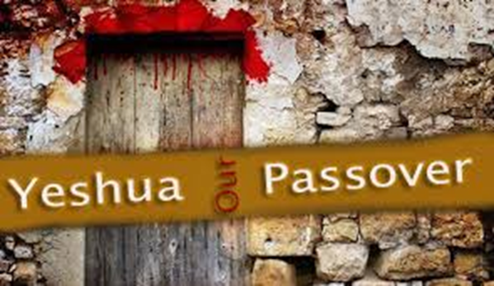
Important Elements for Passover Seder
- Two white candles – Lit by the mother/woman
- Matzah – (Regular or Gluten Free)
- Large white dinner napkin
- Horseradish – Be sure to get the pure hot stuff!
- Parsley
- Charoset/Apple Mixture (See recipe below)
- Small Bowl of Salt water
- Wine/Grape Juice – your preference
- Roasted Lamb Shank Bone (We have purchased this at a meat market (Tony’s Market) and cooked in the oven)
- Haggadah – “The Telling” – Small booklet to follow. The father should lead the Seder.
- Bowl of water & towel – for washing of hands
- An extra place setting for the Prophet Elijah – we anticipate his coming to our Seder.

Basic Recipe – Charoset/Apple Mixture
4 – Honeycrisp or Gala apples, chopped in ¼” pieces
1 cup creamed honey
1 cup chopped walnuts
2 tsp cinnamon

Stir together in bowl with a large spoon.

Get Rid of Leaven in Your Home
The idea of spring cleaning began with preparation for the Feast of Passover/Unleavened Bread. In Ex 12:19-20 it says, “For seven days no leaven shall be found in your houses…you shall eat nothing leavened; in all your dwellings you shall eat only unleavened bread.” Leaven represents sin, so we spend a day getting rid of all of the leaven in our home, ie…crackers, bread, yeast goods, etc. We put them all in a box and take them out of the home (put them in the garage). We vacuum up all crumbs in the home. (A good place is in the cupboard where the toaster sits 😊).

Game of Feathers & Wooden Spoons (for children in the home)
Provide each child a feather and wooden spoon. Hide small croutons (leaven) around the home and tell the children to go find the leaven. When they find one, have them use the feather to scoop the crouton onto the wooden spoon and put it in a paper bag. Once they find all of them, talk to the children about why we need to get rid of the leaven in our physical homes (our spiritual hearts). If able to, build a fire in the firepit and put the paper bag into the fire to burn up the sin. It is a good aroma to our Father, Yehovah, that we are ridding our lives of our sin.
The Passover Meal
Feel free to have whatever you want to have as your Passover Meal. Some choose to have lamb, but you don’t have to. You can serve roast beef, or chicken, Italian dish, whatever you enjoy. We recommend that you don’t serve pork as it is not kosher.

